DSA0504-Query processing for Data Science Name: Sahasra V
Reg no:192424234

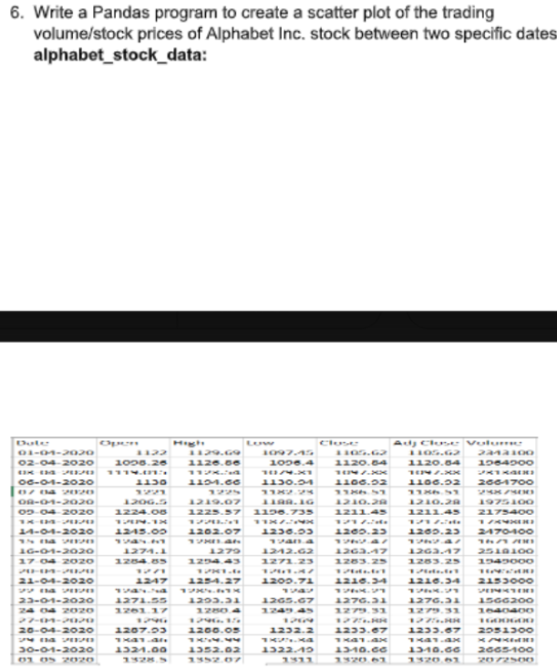

Aim
To create a scatter plot showing the relationship between the trading volume and stock prices (Close price) of Alphabet Inc. stock between two specific dates using the Pandas library.

Algorithm
- Import Pandas and Matplotlib libraries.
- Read the alphabet_stock_data.csv file into a DataFrame.
- Convert the Date column to datetime format and filter the required date range.
- Plot a scatter graph using Volume on the X-axis and Close on the Y-axis.
- Display the scatter plot with title and axis labels.

CODE:
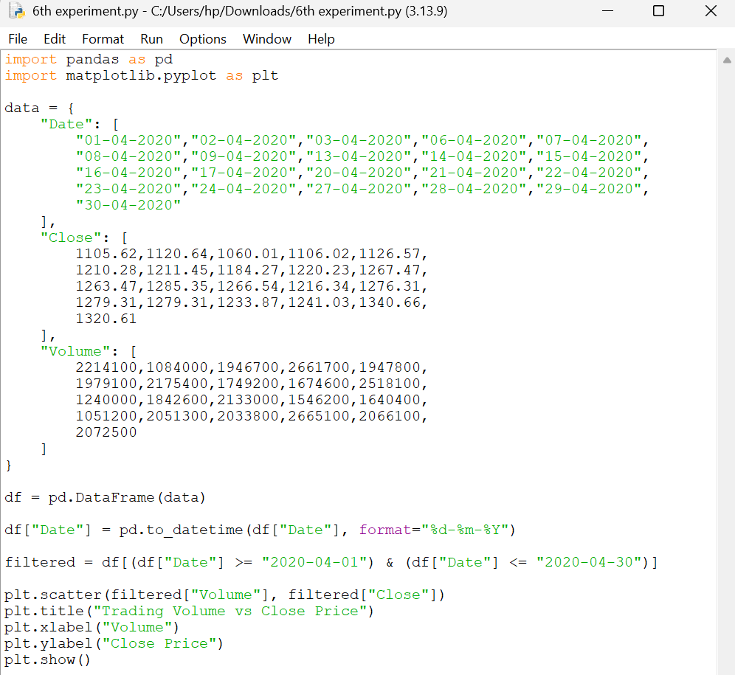

OUTPUT
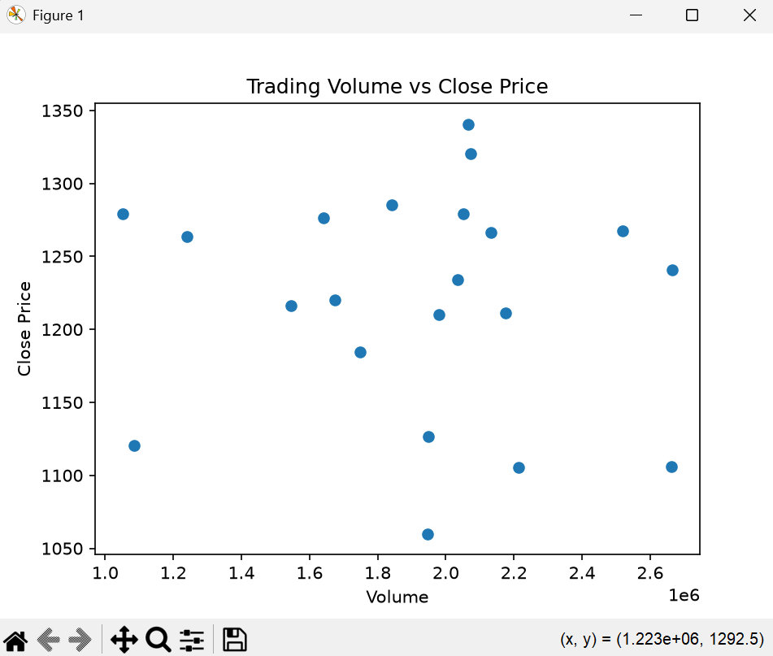

RESULT:
A scatter plot is generated showing the relationship between the trading volume and the closing stock price of Alphabet Inc. for the selected date range (01-04-2020 to 30-04-2020).

Question 7: Create a Pivot Table and Find the Maximum and Minimum Sale Value

Aim
To create a pivot table and determine the maximum and minimum sale value of each item using Pandas.

Algorithm
- Import the Pandas library.
- Create the sales dataset.
- Calculate the sale value (Units × Unit Price).
- Create a pivot table using Item as the index with max and min aggregation.
- Display the pivot table.

CODE:
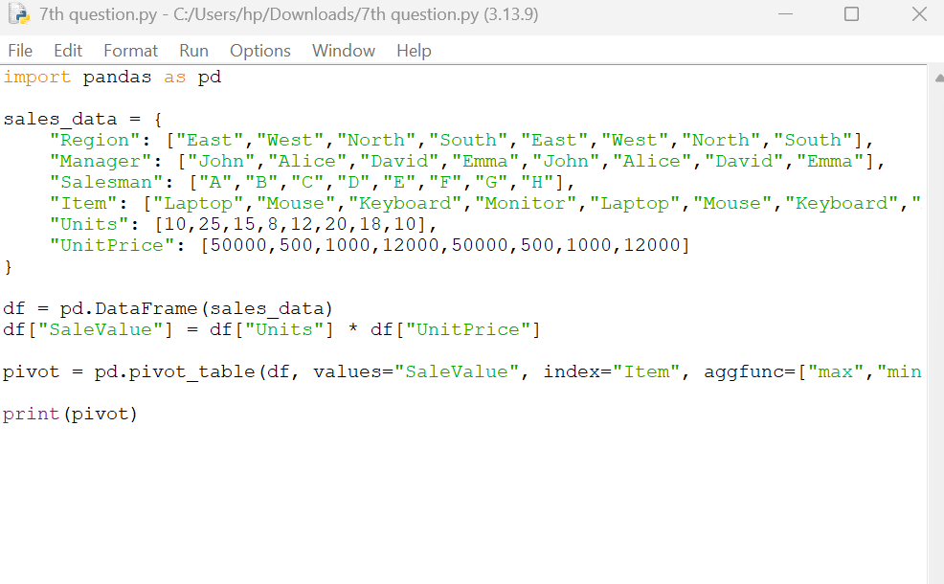

OUTPUT:
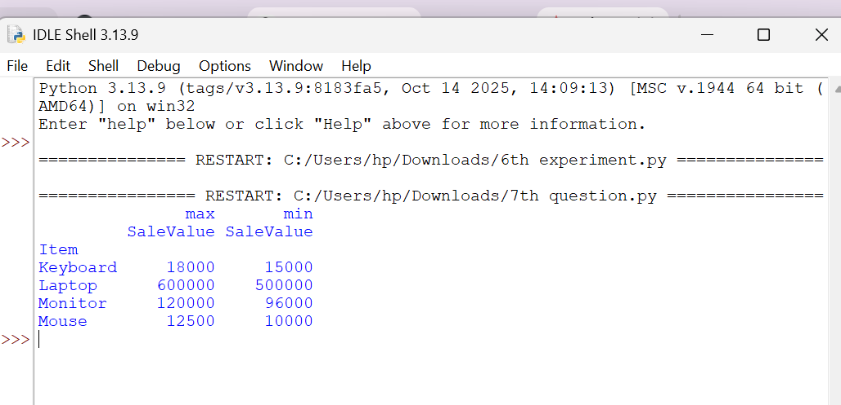

Result
The pivot table was successfully created, displaying the maximum and minimum sale value for each item.

